


Estate Planning (IHT)
Functional Specification

Adviser Evolution
Version 0.03
Date 14 Nov 2006
Author Julian Govier
Table of Contents

1 Change Control History 4
1.1 Future Considerations 4
1.2 Associated Documents 4
2 Introduction 5
3 Functional Requirements 7
3.1 Estate Planning Framework 9
3.1.1 Purpose 9
3.1.2 Navigation 9
3.1.3 Commands 10
3.2 Estate Planning – Current Position EP1 10
3.2.1 Filter Bar 12
3.2.2 Estate EP1-A 12
3.3 Breakdown / Key 14
3.4 Value of Estate on Death EP3 15
3.4.1 Filter Options 16
3.4.2 Fields 17
3.4.3 Commands 19
3.5 Assets written in trust EP4 20
3.5.1 Filter Options 21
3.5.2 Fields 21
3.5.3 Commands 23
3.6 Lifetime Gifts GD1-2 24
3.6.1 Lifetime Gifts – Add Taxable Gifts View 24
3.6.2 Lifetime Gifts – Add Chargeable Gifts View 25
3.6.3 Filter Options 25
3.6.4 Fields 25
3.6.5 Commands 28
3.7 Gift Detail GD1 28
3.7.1 Fields 29
3.7.2 Commands 30
3.8 IHT Tax Assessment IT1-1 & IT1-2 30
3.8.1 IHT Tax Assessment – 1st Death scenario IT1-1 32
3.8.2 IHT Tax Assessment – 2nd Death scenario IT1-2 32
3.8.3 Fields 33
3.8.4 Spousal Transfer 35
3.8.5 Reduction in Estate on 1st Death 37
3.8.6 Commands 40
3.9 Trust Changes 40
3.9.1 Trust Details TD1 41
3.9.2 Fields 41
3.9.3 Commands 43
3.10 Checking for existence of Will 43
3.10.1 Will Confirmation WC1 44
3.10.2 Gifted out of estate on death 47
3.11 System Impact Analysis 50
3.11.1 New fields required in Financial Review (fact find pages) 50
3.11.2 Suitability Reports 51
3.11.3 Assumptions 51
4 Appendices 53
4.1 Calculated Exempt Transfer to spouse 53
4.1.1 Scotland 54
4.1.2 England & Wales 55
4.1.3 Northern Ireland 55
4.2 Calculated Reduction on 1st death 56
4.3 Calculation of IHT Taper Relief for Gifts 57
4.4 Assumptions 57
5 Authority & Responsibility Sign Off 58

Change Control History

Version | Author | Date | Details | Reviewed by/Issued to | Date
0.01 | Julian Govier | 13 Sep 06 | Functional specification for Estate Planning (IHT) Financial Objective
0.02 | Julian Govier | 01 Nov 06 | Specification re-worked following client review.  As Recent legislative changes on trust mean that some advice will not immediately affect IHT position it is not appropriate to include a course of action section.  Ability to select assumption for Scottish and Northern Ireland laws of succession  Additional information needed to determine the rules affecting a trust where selected on a provision to determine if it is still liable to IHt  New provisions (quotes) require more information on trust to enable suitable reason why paragraphs to be selected.
0.03 | Julian Govier | 14 Nov 06 | Changes made to calculation of nil rate band for taxable estate on IHT Tax Assessment. Also amendment to Lifetime Gifts to show individual chargeable

Future Considerations

The current functionality is limited to allowing individual 1st death scenario and simultaneous death example for married couples.

For the initial implementation the system will not calculate any agricultural relief that may be available. Instead the user will have the option to include the value of the relief as a reduction of the estate subject to IHT.

For the initial implementation the system will not calculate any business relief that may be available. Instead the user will have the option to include the value of the relief as a reduction of the estate subject to IHT.

Associated Documents

This document should be read in conjunction with:

Version | Document Title | Description
1.00 | AE Standard Classes V4.0.vsd | Details standard AE base class screen format
1.00 | AE Common Components | Details standard AE common components
1.00 | AE – Needs Analysis – Estate Planning (IHT) – 1657060.vsd | Wireframes document
1.00 | AE - Existing Provisions | Specification of the existing provisions page used for objective analysis
1.00 | AE - Advice Process 1618641.doc | Specification of the advice process that provides the framework that the inspector sits inside
1.00 | AE - Case Management 1615731.doc | Specification that describes the mechanism for the inclusion of the need area in the advice process.
1.00 | AE Plans - Additional Functional Spec.doc | Specification that detail the existing trust and beneficiary details that will be enhanced to enable estate planning calculations to take into account trust written (part written) for the benefit of the partner
1.00 | AE - Quotations and New Business Applications 1619795.doc | Specification that details the method of identifying that a new provision should be tten under trust. This function will not be active in the initial implementation of estate planning
1.00 | AE – IHT Calculations. xls | Spreadsheet that provides worked examples of the IHT calculation.
Unless specified AE Base Classes, Common Components and Standards should be adhered to.

All Intellectual Property Rights are and shall remain the property of Independent Specialist Technology (UK) Ltd unless otherwise stated.

Introduction

The document defines how a user can review the effects of the death of the client being assessed and where a joint financial review is being carried out, the death of the partner and simultaneous death of married couples / civil partnerships. For the purposes of the calculation death is assumed to be immediate.

The purpose of the module is to provide a simplified position (based on the information entered into the financial review) that will form the basis for an estate planning discussion.

It is not possible to provide an accurate assessment of inheritance tax situation in every instance so this area includes a number of user adjustments to refine the calculations performed by the system.

The tax implication of non-domiciled individual is specifically excluded for this implementation as this requires a detailed analysis to determine if the property is held in the UK. This also applies to the non domiciled spouse exemption on gifts which limits the value of exempt transfers. The wills section of the fact find will include the ability to record that an individual is not deemed UK domicile for IHT purposes and the system will not perform an assessment where this is selected.

The estate planning module is contained in the core financial objectives inspector framework which enables the user to confirm the client(s) requirements in the event of the death of the individual being assessed. The user can review the current position.

Inheritance Tax (IHT) is payable on the value of the deceased estate is above the IHT threshold (held as a system parameter). A person’s estate is made up of:
- Assets solely owned
- Their share of any jointly owned assets
- assets held in a trust in which the deceased had an immediate post-death interest, a disabled person’s interest, or a transitional serial interest
- Assets that have been gifted away, but they have retained an interest in (gift with reservation).
- The value of an alternatively secured pension fund (ASP) from which the deceased benefited as the original scheme member, or as a dependant who received benefits from the left over ASP fund of an original scheme member.

Transfers of property and gifts between spouses, no matter how large in value, are exempt from Inheritance Tax.
Note: There is an exception where a UK domiciled spouse makes a transfer to their spouse who is non-domicile in the United Kingdom. In this case a limit is applied. The current implementation will not perform an assessment where this occurs.

Where gifts has been made within seven years of the death the system will calculate the effects on the inheritance tax calculation (see Calculation of IHT Taper Relief for Gifts)

Functional Requirements

Estate Planning (IHT) is a default financial objective within a personal financial review and is always available. It is only included once in the financial objectives framework when included, including joint individual financial reviews.

Access to the module is made from the financial objectives framework which displays all financial objectives for a case review.

The relative position of the module in the financial objectives framework is set based on the agenda (general objectives) set for the review, although the module can be moved within the framework to another category or another position in its current group.

This area does not have a shortfall and is displayed as a single bar based on the following:

Where the Marital Status of one of the individuals being assessed is not set then regardless of the status of the financial review the system will prevent access to the area and the status is set to Insufficient Information. On selecting to review the area the system displays an error dialog advising that the marital status of the individual(s) need to be set to perform an assessment

Where an individual being assessed (or there partner) is recorded as not UK domicile for IHT purposes the system will indicate that no assessment has been performed. On selection of the link on the financial objectives grid the system will display an information box that states that no assessment has been carried out due to an individual being non domicile.

Otherwise the system indicates the status of the area depending on the status of the assessment:

- If the page status is Incomplete then the graph displays a status of Assessment Incomplete.
- If the page status is Review Required then the graph displays a status of Review Required.
- Otherwise the graph displays a status of Assessment Complete.

See AE - Advice Process 1618641 specification for details of graphical display.

On selection of the link the inspector will be invoked

and the user will be presented with the Current Position page which initially displays:
- For single individual financial review and joint reviews where the system identifies that the individuals are not married the system displays the estate position assuming the death of the client.
- For joint financial review where the system identifies that the individuals are married / civil partners the system displays the estate position assuming the joint death of the individuals

The system displays the value of the estate on occurrence of the scenario with a link to review
- The calculated value of the estate prior to the scenario occurring (i.e. the current net value of the estate)
- The changes that occur to the value due to the scenario and displays the value of the estate on death.

The system calculates the taxable estate by
- Deducting assets that have been written in trust and not remaining in the financial plan on the death (see 1)
- Adding the value of any taxable gifts (see Calculation of IHT Taper Relief for Gifts for details)

The user can review a breakdown of the calculations.

The system then displays the calculated net inheritance tax payable on the taxable estate. The user can select to see a breakdown of this calculation, which takes into account, nil rate band, tax already paid on gifts and any taper relief applied.

The system displays the calculated value of the estate passed to dependants and the effective rate of IHT on the taxable estate by adding back assets written in trust, exempt gifts and the effects of new provisions and then deducting the value of taxable gifts.

The system displays a 3D pie chart that displays proportion of the value of the estate on death payable in tax, in trust and the net estate.

Estate Planning Framework

The Estate Planning assessment is held in an inspector dialog with left hand menu and toolbar

It consists of a

single page – “Current Position”

The screen includes a strap line that states “Estate Planning for [name of individual(s) being assessed]

Purpose
The Inspector enables the user to r
eview the current position in respect of inheritance tax in the event of the death of the client and where a joint financial review is conducted, the death of the partner and joint death of both individuals

Navigation
Command | Comments
Estate Planning Objectives

IMPORTANT
On attempting to Invoke the estate planning module then
If the Have you made a will?” question on the estate planning page is “Not Disclosed”, ”Not Answered” or “Not Known” for any individual being assessed the following warning is displayed:
“[name(s)] [has/have] not indicated whether a valid will exists. This must be set before an estate planning assessment can be made. Do you wish to continue?”
Options: Yes On selection invoke 3.12.1 - Will Confirmation WC1
No (Default) On selection close dialog
Else if the Have you made a will?” question on the estate planning page is “No” for an individual being assessed and one or more property assets include a gifted out of estate for the same individual then following warning is displayed:
““[name(s)] [has/have] have indicated that they are gifting assets on death, but [he/she/they] [has/have] no will”. You may continue and record that a will exists or remove the gifting from estate in the financial review. Do you wish to continue?
Options: Yes On selection invoke 3.12.1 - Will Confirmation WC1
No (Default) On selection close dialog
Else the system invokes the appropriate page of the estate planning modules
Current Position | Always displayed and read only  Page status is initially set to Review  On selection of the page set status to Complete  If page not reviewed within set time limit then set status to Review  Page is a summary of the current position and provides a number of links that enable the user to view a more detailed breakdown of how each figure has been calculated.

Commands
Command | Comments
Estate Planning
Page Status | Always displayed  The page / dialog status is a standard control that is used on all needs analysis screens. It is used to display / set the current status of the page / dialog being reviewed.  The control is view in the header as a link but on selection reverts to a list with the following options:  - Incomplete  - Complete  - Review (initial default)  The system contains a global parameter that determines the length of time prior that a page can remain in the status of “Complete” and the current case status NOT is Application or Completion. This is set as a number of days after which the status is automatically set to “Review”  Note: If page status is “Incomplete” then time limit does not apply  The page status cannot be changed by the user when the page is being reviewed in read only mode (see navigation above).  Where the status of a sub dialog is “Incomplete” then the status of the page it is set to “Incomplete” by the system and cannot be set to another status.  Where the status of a page is set to “Complete” then the status of any sub dialog is also set to “Complete” (i.e. if all the sub dialogs are “Complete” and / or “Review”)  Note: the initial default status of all sub dialogs is “Review”.  The system also displays the status of the page after the link in the left hand menu   Complete Page is complete   Incomplete Page is incomplete   Review Page requires a review
Apply | On Selection:  If any mandatory fields are incomplete then display the following message:  The following fields are incomplete:  <List of fields>  On selection of OK set focus to the first incomplete field.  Else apply changes and close inspector.
Cancel | On Selection:  Abandons any changes made (including status) and close inspector.
Assumptions | Toolbar option  On selection invokes Financial Objectives Assumption (AS1) dialog which contains the default system assumptions for calculation of shortfalls and the location of estate assumption for the client(s)
View | Menu Option  On Selection:  Contains the following sub menus:  - Assumptions (same as assumptions toolbar option)

Estate Planning – Current Position EP1

Current Position is the only page of the Estate Planning inspector dialog. It is used to review the details of the calculation of the value of the estate of the individuals that is passed on to dependants in the event of the death of the client and if a joint review is being carried out that of the death of the partner and joint death of both individuals

All the values displayed on the page are calculated by the system and summarised to show the intermediate steps to calculate the value passed to dependants, including the net inheritance tax payable.

Where all the individuals being assessed have a marital status of married then the system assumes that they have a spousal relationship (marriage or civil partnership) and the system transfers all the assets of the deceased to the surviving spouse (subject to will status and rules of intestacy for the location of estate (see Assumptions and Calculated Exempt Transfer to spouse) and Gifted out of estate on deathth.

Where the individuals are not married (i.e. one of the individuals does not have a marital status of married) the system assumes that inheritance tax is payable on the assets of the individual. In this case a joint death is not displayed

The system also displays a 3D pie chart that displays proportion of the value of the estate on death payable in tax, in trust and the net estate.

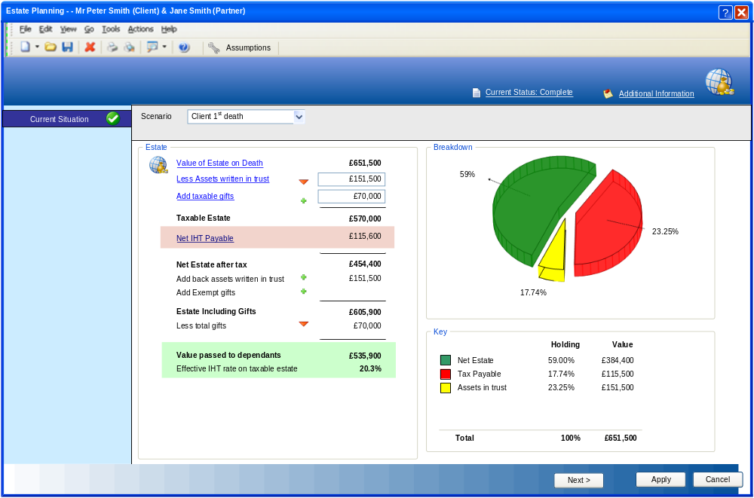

Filter Bar

This page includes a filter bar with the options to view the results based on today’s value or future values (Default)

Field | Comments
Filter Bar
Scenario | Always displayed, but only enabled if a joint review is being carried out  List of scenarios with the following options  - Client 1st Death (default for single review or joint review where NOT married)  - Partner 1st Death  - Joint Death (default for joint review where married) – Not included if individuals being assessed are NOT married  On selection the system display the estate planning calculations for the selected scenario

Estate EP1-A

This section contains the calculation results for the scenario being reviewed with links to view the underlying items that make up the high level summary items

Estate – Current Position

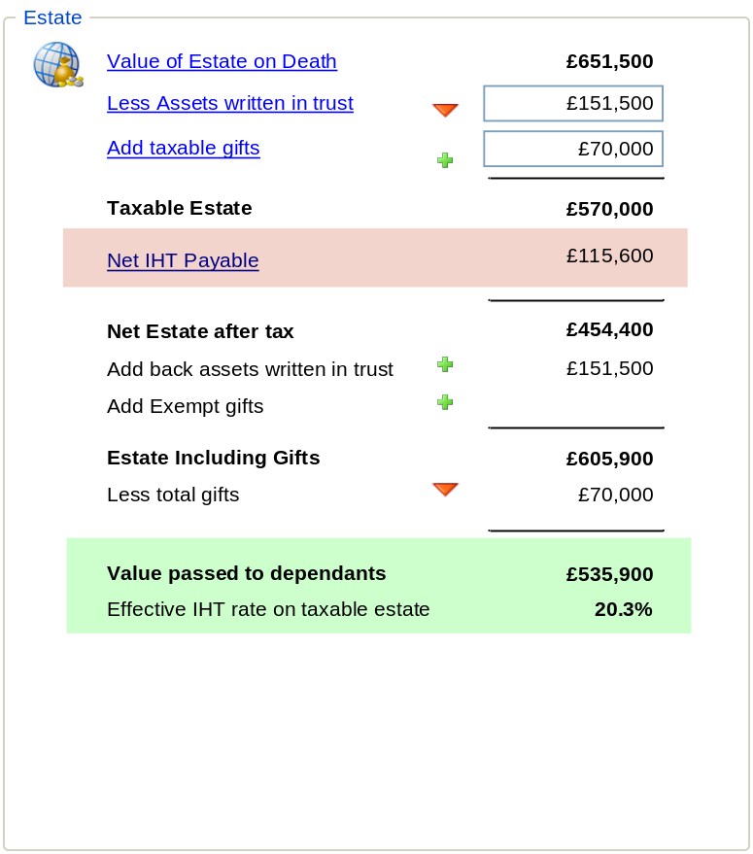

Command | Comments
Estate Planning
Value of Estate on Death – link | Always displayed and enabled  Link  On selection invokes Value of Estate on Death EP3 dialog populated with calculations for the selected scenario
Value of Estate on Death – value | Always displayed and read only  Label – currency (no decimals) - Bold  This is the value of the estate calculated from Value of Estate on Death EP3 for the selected scenario  Value A
Less Assets written in trust - link | Always displayed and enabled  Link  On selection invokes Assets written in trust EP4 dialog populated with calculations for the selected scenario
Less Assets written in trust - Value | Always displayed and read only  Label – currency (no decimals)  This is the value of the Assets written in trust EP4 for the selected scenario  Value B
Add Taxable Gifts - link | Always displayed and enabled  Link  On selection invokes Lifetime Gifts GD1-2 dialog populated with calculations for the selected scenario
Add Taxable Gifts - Value | Always displayed and read only  Label – currency (no decimals)  This is the value of taxable gifts from the Lifetime Gifts GD1-2 for the selected scenario  Value C
 | Changes to Estate Planning EP5
 | Changes to Estate Planning EP5
 | Changes to Estate Planning EP5
 | Changes to Estate Planning EP5
Taxable Estate | Always displayed and read only  Label – currency (no decimals) - Bold  Derived value  Value = Value A – Value B + Value C  Value F
Net IHT Payable - link | Always displayed and enabled  Link  On selection invokes IHT Tax Assessment IT1 dialog populated with calculations for the selected scenario
Net IHT Payable - Value | Always displayed and read only  Label – currency (no decimals)  This is the value of Net IHT payable from IHT Tax Assessment IT1 for the selected scenario  Value G
Net Estate after tax | Always displayed and read only  Label – currency (no decimals) - Bold  Derived value = Value F – Value G  Value H
Add back assets written in trust | Always displayed and read only  Label – currency (no decimals) - Bold  Derived value = Value B  Value I
Add Exempt Gifts | Always displayed and read only  Label – currency (no decimals)  This is the value of exempt gifts from the Lifetime Gifts Lifetime Gifts GD1-2 for the selected scenario  Value J
Estate including Gifts | Always displayed and read only  Label – currency (no decimals) - Bold  Derived value = Value F – Value G  Value L
Less Total Gifts | Always displayed and read only  Label – currency (no decimals)  This is the value of all gifts from the Lifetime Gifts GD1-2Lifetime Gifts for the selected scenario  Value M
Value passed back to dependants | Always displayed and read only  Label – currency (no decimals) - Bold  Derived value = Value L – Value M  Value N
Effective IHT rate on taxable estate | Always displayed and read only  Label – percentage (99.99%) - Bold  Derived value = round(Value G / Value F),4)

Breakdown / Key

This section contains a 3D pie chart that represents the proportion of the Value of the Estate on Death (Including any new provisions when viewed as course of action) taken by the Net IHT Payable and existing assets in trust.

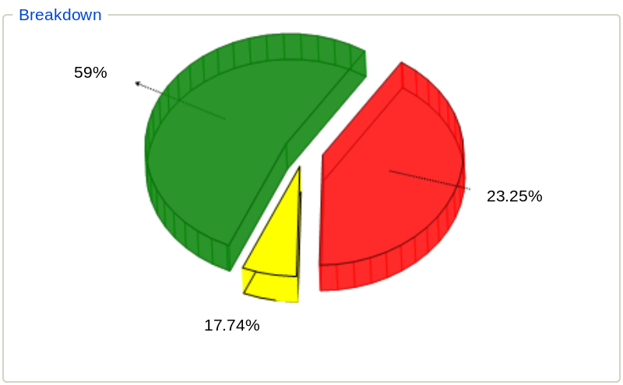

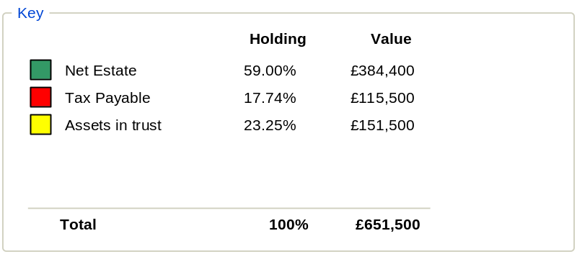

Field | Comments
Estate Planning
Graph | Read only  3D Pie chart  chart represents 100% of Value on Death for scenario (Value A)  Sections are as indicated in key
Key | Read Only  Colour Coded to match 3D pie chart  Colour Item Holding Value  Green Net Estate A – (G+B)/ A A  Red Tax Payable G / A G  Yellow Assets In Trust B / A B

Value of Estate on Death EP3

The Value of Estate on Death dialog is a read only dialog that lists all the items that are included in the current value of the estate and the net changes to the value of estate on death (i.e. the change in the value of an asset as the result of the scenario – receipt of death benefit, receipt of 101% of the value of a bond).

The system displays each item providing details of its current value and value on death based on the scenario selected.
Note: in some cases the current value may be nil as value is only realised on death (for example a term assurance policy).

The system displays these in a standard grid with grouping and managed column. The user can select to review the details of an individual asset by selecting the item in the list and selecting the view toolbar option (also double click event and from mouse shortcut menu).

The user can select to include or exclude any provisions that have not yet commenced (pipeline applications) by selection of a filter.

The system displays the calculated value of the current estate, the sum of net changes to the estate on death and the total value of the estate on death.

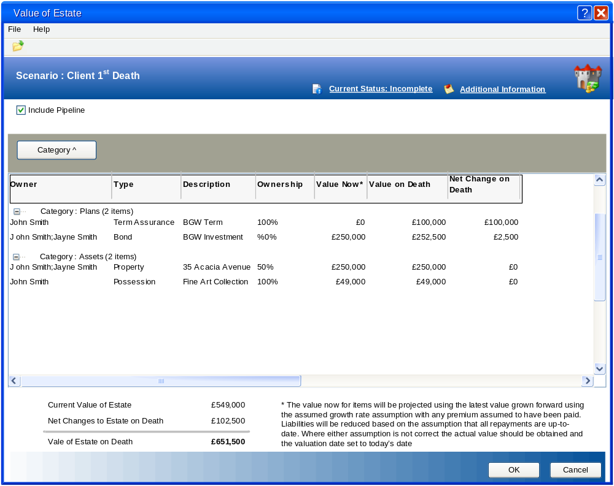

Filter Options
Command | Comments
Value of Estate
Include Pipeline | Always displayed and enabled  Checkbox (default – deselected)  On selection the list includes any pipeline provisions that have a value on death and totals adjusted  On deselection the quote list excludes all pipeline provisions and totals adjusted

Fields
Field | Comments
Value of Estate
Note: The grid is also used to display Assets written in trust EP4, but with different default columns and included items
Estate List Grid | This is a filtered view of the provisions (plans, investment holdings, cash accounts, liabilities and assets) that are owned (part owned) by the individual(s) being assessed for the scenario selected on Filter Bar of the main page where there is either current estate value and / or a value on death.  This grid is a standard grid control (i.e. grouping and manage column functions are enabled) and contain the following columns (Columns can be wrapped to 2 lines to include long names, descriptions):  Initial defaults displayed  Owner Name of the owners of the provisions / holdings  Type Type of provisions / holding  Description Description of the provisions  Date Date that the quote was created  Percentage Owned Percentage of the provisions owned by the individual(s) being assessed  Value Now* The value of the provisions at today’s date based on the ownership percentage. Liabilities are displayed as negative values. If the value of the provision is in the past then the system projects this to today using the growth rate assumptions (including adding any assumed premiums – for liabilities the sum calculates any reduction since the last outstanding balance date).  Value on Death The Value of the provisions based on the death of the individual(s). Liabilities are displayed as negative values  Net Change on Death The variance between the Value on death and current value  Optional columns  Ownership Ownership of an asset  Plan Type Plan Type of a plan  Product Type Product type of a plan  Provider Name of the provider  Status Current status of the provision  Payment /Premium Premium / Payment for plan / liability  Frequency Frequency of payment / premium  Start / Acquired Start date of a plan or acquisition date of an asset  Cost The cost of acquisition for a provision  Value The value of the provisions  Date Valued The date the last valuation  In Trust Text description of the trust status of the provision**  Trust Value on Death Value of the provisions that is in trust on death (i.e. Value Now – excluded amount (percentage of value now or amount)***  Passed to Spouse Text description of whether a percentage of the asset is fully passed to the spouse of the individual(s)****  The user can double click and entry to invoke the appropriate dialog (plan, investment holding, cash account or asset) pre-populated with details of item. (Also available from toolbar options and mouse shortcut options).  * The system indicates next to the value that it has been projected (this may be a column that has no heading. The following text is displayed in the footer “The value now for items will be projected using the latest value grown forward using the assumed growth rate assumption with any premium assumed to have been paid. Liabilities will be reduced based on the assumption that all repayments are up-to-date. Where either assumption is not correct the actual value should be obtained and the valuation date set to today’s date”  ** If the provision is held in trust then  If Remains in estate on death selected then  If Date excluded from estate in future then  Value = Chargeable until [date excluded from estate]  Else  Value = Yes  Else  Value = Yes  End If  Else if the proportion of the provision owned by the individual is Gifted to others selected then  If Remains in estate on death selected then  If single death scenario then  Value = [value or percentage] to spouse  Else  Value = Yes  End if  End if  Else  Value = No  End If  *** In a joint death scenario the system bases the calculation on assessing the death of the oldest individual first and any exclusion is applied to that individual only. Any exclusion applied to the younger individual is ignored as they are assumed to have no surviving spouse.  **** If ownership of asset = Tenants In Common and Spouse / partner included as beneficiary NOT selected then  Value = Yes  Else ownership of asset = Tenants In Common and Spouse / partner included selected then  Value = Passes to other beneficiaries [provision value -Amount or 1- percentage]  Else  Value = Null  End If  Note: Spouse / partner included and Not passed to spouse functions are not in Alpha Release of AE and are enhancement as part of this functionality
Current Value of Estate | Always displayed and read only  Label – currency (no decimals) - Bold  Sum of Current Value column for items displayed in grid  Value A1
Net Changes to Estate on Death | Always displayed and read only  Label – currency (no decimals) - Bold  Sum of Net Change on Death column for items displayed in grid  Value A2
Value of Estate on Death | Always displayed and read only  Label – currency (no decimals) - Bold  Sum of Value on Death column for items displayed in grid (A1+A2)  Value A

Commands
Command | Comments
Value of Estate
Dialog Status | Always displayed and enabled except read only if current case context is Application or Completion.  The dialog status is a standard control that is used on all needs analysis screens. It is used to display / set the current status of the page / dialog being reviewed.  The control is view in the header as a link but on selection reverts to a list with the following options:  - Incomplete  - Complete  - Review (initial default)  The system may set the dialog status automatically on entry or require the user to make a selection.  The system contains a global parameter that determines the length of time prior that a dialog can remain in the status of “Complete” and the current case status NOT is Application or Completion. This is set as a number of days after which the status is automatically set to “Review”  Note: If dialog status is “Incomplete” then time limit does not apply
Additional Information | Always displayed and enabled  Link  On selection standard additional information dialog is invoked populated with any notes associated with the dialog
Open | Always displayed and enabled  Toolbar option  On Selection  If no item is highlighted then display error “No item selected”  Else invoke the appropriate dialog (plan, investment holding, cash account or asset) pre-populated with details of item.  (double click item or selection of open from mouse shortcut menu also available)
OK | On Selection:  If Include Pipeline is selected then the value of estate on death passed back to main page includes pipeline provisions  Changes are stored pending next save and close inspector.
Cancel | On Selection:  Abandons any changes made and close inspector.

Assets written in trust EP4

The Assets Written in Trust dialog is a read only dialog that lists all the plans, investment holdings, cash accounts and assets that are held in trust.

This dialog is invoked by selection of the Less Assets written in trust on Estate Planning – Current Position EP1 page

It is a variant of the Value of Estate on Death EP3 dialog but with different column heading initially displayed.

The system displays any provisions (asset, plan or directly held investment) where the user has recorded that the items is held in trust and for each item provides details of the trust and the value on death that is not being gifted to the spouse.
Note: For a joint scenario it is assumed that the Will has been written to avoid passing assets to spouse that are held in trust where the partner is a beneficiary and so in this instance the system will ignore any portion that is under trust to the spouse and assume the entire asset is held in trust. See Trust Changes

Where the provisions is held in trust, but is not exclude from the estate on death (i.e. the provision remains in estate on death and the date of exclusion is in the future then the system excludes the value from assets written under trust (i.e. there is no Trust Value on death).
Note: A corresponding lifetime transfer is linked to the provisions when

The system displays these in a standard grid with grouping and managed column. The user can select to review the details of an individual asset by selecting the item in the list and selecting the view toolbar option (also double click event and from mouse shortcut menu).

The user can select to include or exclude any provisions that has not yet commenced (pipeline applications) by selection of a filter.

The system displays the sum of the trust value on death.

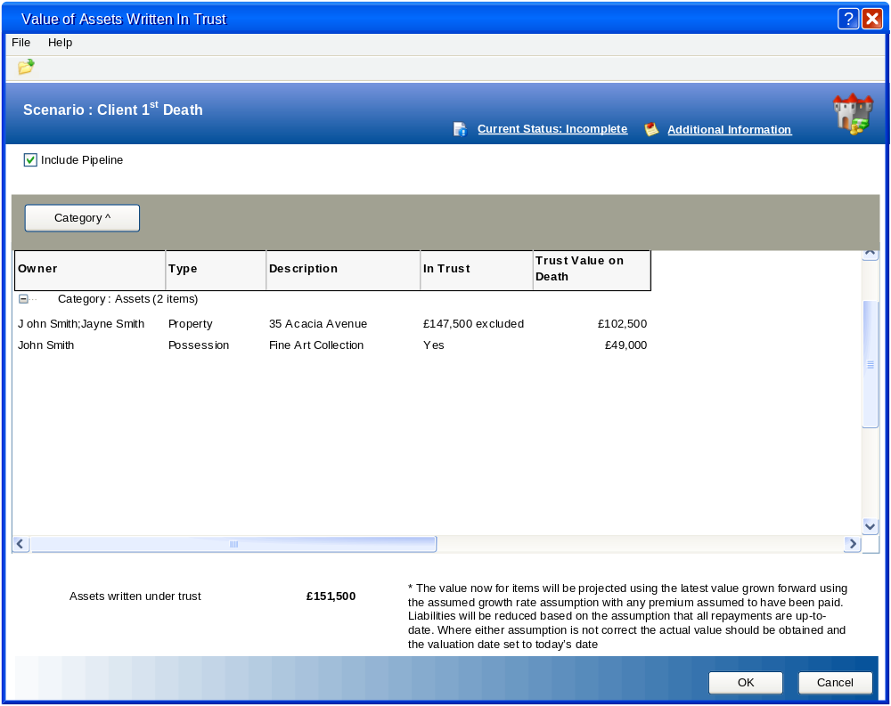

Filter Options
Command | Comments
Value of Estate
Include Pipeline | Always displayed and enabled  Checkbox (default – deselected)  On selection the list includes any pipeline provisions that have a value on death and are set to be “In Trust” and totals adjusted  On deselection the quote list excludes all pipeline provisions and totals adjusted

Fields
Field | Comments
Value of Estate
Note: The grid is also used to display Value of Estate on Death EP3, but with different default columns and included items
Estate List Grid | This is a filtered view of the provisions (plans, investment holdings, cash accounts, liabilities and assets) that are owned (part owned) by the individual(s) being assessed for the scenario selected on Filter Bar of the main page where there is a value on death and the item is “In Trust”  This grid is a standard grid control (i.e. grouping and manage column functions are enabled) and contain the following columns (Columns can be wrapped to 2 lines to include long names, descriptions):  Initial defaults displayed  Owner Name of the owners of the provisions / holdings  Type Type of provisions / holding  Description Description of the provisions  In Trust Text description of the trust status of the provision**  Trust Value on Death Value of the provisions that is in trust on death (i.e. Value Now – excluded amount (percentage of value now or amount)***  Optional columns  Percentage Owned Percentage of the provisions owned by the individual(s) being assessed  Value Now* The value of the provisions at today’s date based on the ownership percentage. Liabilities are displayed as negative values. If the value of the provision is in the past then the system projects this to today using the growth rate assumptions (including adding any assumed premiums – for liabilities the sum calculates any reduction since the last outstanding balance date).  Value on Death The Value of the provisions based on the death of the individual(s). Liabilities are displayed as negative values  Net Change on Death The variance between the Value on death and current value  Ownership Ownership of an asset  Plan Type Plan Type of a plan  Product Type Product type of a plan  Provider Name of the provider  Status Current status of the provision  Payment /Premium Premium / Payment for plan / liability  Frequency Frequency of payment / premium  Start / Acquired Start date of a plan or acquisition date of an asset  Cost The cost of acquisition for a provision  Value The value of the provisions  Date Valued The date the last valuation  In Trust Text description of the trust status of the provision**  Trust Value on Death Value of the provisions that is in trust on death (i.e. Value Now – excluded amount (percentage of value now or amount)***  Passed to Spouse Text description of whether a the percentage of the asset is fully passed to the spouse of the individual(s)****  The user can double click and entry to invoke the appropriate dialog (plan, investment holding, cash account or asset) pre-populated with details of item. (Also available from toolbar options and mouse shortcut options).  * The system indicates next to the value that it has been projected (this may be a column that has no heading. The following text is displayed in the footer “The value now for items will be projected using the latest value grown forward using the assumed growth rate assumption with any premium assumed to have been paid. Liabilities will be reduced based on the assumption that all repayments are up-to-date. Where either assumption is not correct the actual value should be obtained and the valuation date set to today’s date”  ** If the provision is held in trust then  If Remains in estate on death is selected and exempt from is in the future then  Value = Exempt [date except from]  Else if spouse / civil partner include as beneficiary then  Value = Yes – [value or percentage] to others  Else  Value = Yes  End if  Else  Value = No  End If  *** In a joint death scenario the system basis the calculation on assessing the death of the oldest individual first and any exclusion is applied to that individual only. Any exclusion applied to the younger individual is ignored as they are assumed to have no surviving spouse.  **** If ownership of asset = Tenants In Common and Gifted from estate NOT selected then  Value = Yes  Else ownership of asset = Tenants In Common and Gifted from estate selected then  Value = [value or percentage] excluded  Else  Value = Null  End If  Note: Remain in estate and Gifted from estate functions are not in Alpha Release of AE and are enhancement as part of this functionality
Value of Estate on Death | Always displayed and read only  Label – currency (no decimals) - Bold  Sum of Trust Value on Death column for items displayed in grid  Value B

Commands
Command | Comments
Value of Estate
Dialog Status | Always displayed and enabled except read only if current case context is Application or Completion.  The dialog status is a standard control that is used on all needs analysis screens. It is used to display / set the current status of the page / dialog being reviewed.  The control is view in the header as a link but on selection reverts to a list with the following options:  - Incomplete  - Complete  - Review (initial default)  The system may set the dialog status automatically on entry or require the user to make a selection.  The system contains a global parameter that determines the length of time prior that a dialog can remain in the status of “Complete” and the current case status NOT is Application or Completion. This is set as a number of days after which the status is automatically set to “Review”  Note: If dialog status is “Incomplete” then time limit does not apply
Additional Information | Always displayed and enabled  Link  On selection standard additional information dialog is invoked populated with any notes associated with the dialog
Open | Always displayed and enabled  Toolbar option  On Selection  If no item is highlighted then display error “No item selected”  Else invoke the appropriate dialog (plan, investment holding, cash account or asset) pre-populated with details of item.  (double click item or selection of open from mouse shortcut menu also available)
OK | On Selection:  If Include Pipeline is selected then the value of Assets written in Trust passed back to main page includes pipeline provisions that are in trust  Changes are stored pending next save and close inspector.
Cancel | On Selection:  Abandons any changes made and close inspector.

Lifetime Gifts GD1-2

The Lifetime Gifts dialog enables the user to review the details of all the gifts given by the individual(s) being assessed.

This dialog is invoked by selection of the Add Taxable gifts link on Estate Planning – Current Position EP1 page and from the Add Chargeable Gifts link on the IHT Tax Assessment IT1-1 & IT1-2 dialog.

The system displays a list of the lifetime gifts recorded in the financial review, but where a joint gift is record in the financial review separate items are displayed with the value based on the split of the gift.
The user can add, amend or delete items from the list (deletion is not allowed if the lifetime gift is either from a jointly gifted item or linked to a provision – see Trust Changes) except where the current case context is Present Advice, Application or Completion.

The system displays a summary of the lifetime gifts for each individual with a total of currently taxable and exempt gifts (this is not dependant on the filter applied to the grid). See Calculation of IHT Taper Relief for Gifts for details of calculation of taxable gifts

Lifetime Gifts – Add Taxable Gifts View

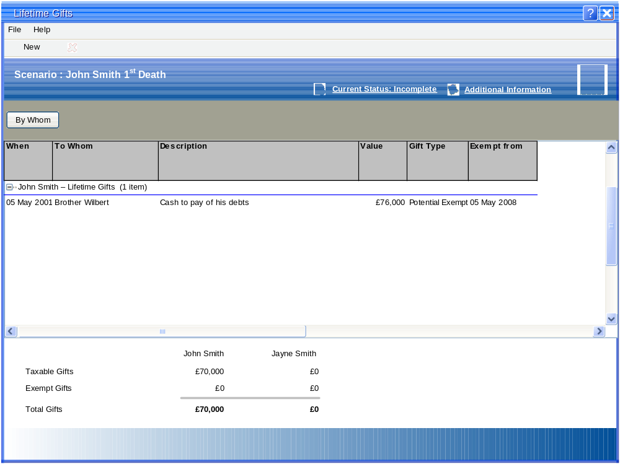

Lifetime Gifts – Add Chargeable Gifts View
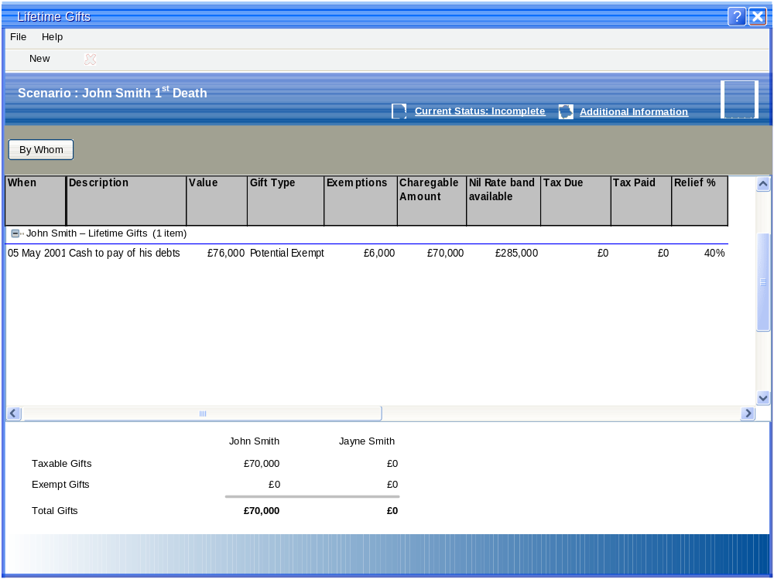

Filter Options
Command | Comments
Lifetime Gifts

Fields
Field | Comments
Lifetime Gifts
Lifetime Gifts List Grid | This is a list of all the lifetime gifts for the individual(s) being assessed based on the filters set  This grid is a standard grid control (i.e. grouping and manage column functions are enabled) and contain the following columns (Columns can be wrapped to 2 lines to include long names, descriptions):  The grid has two default views which are set based on where the dialog is invoked  If invoked from Add Taxable Gifts link on Estate Planning – Current Position EP1 page then  Initial defaults displayed  When The date of the gift  By Whom Who the gift is from (owner of gift) – Joint gift will be displayed multiple time, but with the values split based on the gift – default group item  To Whom Free Format text of the person receiving the gift  Description Description of the reason for the gift  Value Amount of the gift  Gift Type Type of gift (exempt, potential exempt, chargeable)  Exempt from The date the gift became, will become exempt*  Tax Paid The value of any IHT tax paid on making the gift  Else (i.e. invoked from the Add Chargeable Gifts link on the IHT Tax Assessment IT1-1 & IT1-2 dialog)  Initial defaults displayed  When The date of the gift  By Whom Who the gift is from (owner of gift) – Joint gift will be displayed multiple time, but with the values split based on the gift – default group item  Description Description of the reason for the gift  Value Amount of the gift  Gift Type Type of gift (exempt, potential exempt, chargeable)  Exemptions Derived value – value calculated by checking earlier gifts within the last 2 tax years. Exemption granted up to [annual exemption limit] in each financial year. If unused amount in previous tax year this can also be applied. Earliest gift must receives exemption  Chargeable amount If Exempt from date not passed / null or the gift is NOT exempt then this is Value – Exemptions (i.e. any non exempt gift made in last 7 years)  Nil Rate Band Available Derived value – calculated by deducting value of any earlier Changeable items and any gift where gift type = Chargeable that is within 7 year of When. IF value negative then value = 0  Tax Due Derived value – chargeable amount – Nil rate band available * IHT rate  Tax Paid The value of any IHT tax paid on making the gift  Relief % Derived value – lookup based on number of complete years from now to when gift made. (see Calculation of IHT Taper Relief for Gifts for details)  Taper Relief Derived value – Tax Due * Relief%  *If the Gift is exempt then  Value = Date of Gift  Else if the gift id potential exempt then  Value = Date of gift + chargeable period (7 years currently)  Else (i.e. chargeable)  Value = null  End if
Taxable Gifts - Client | Always displayed and read only  Label – currency (no decimals) - Bold  Sum of gift Value where the Exempt from date has NOT been passed or is NULL which where given by the client where joint then value * split percentage)  Value C-1
Exempt Gifts - Client | Always displayed and read only  Label – currency (no decimals) - Bold  Sum of gift Value where the Exempt from date has been passed which where given by the client where joint then value * split percentage)  Value J-1
Total Gifts - Client | Always displayed and read only  Label – currency (no decimals) - Bold  Sum of all gifts which where given by the client where joint then value * split percentage) (C+J)  Value M-1
Taxable Gifts - Partner | Always displayed and read only  Label – currency (no decimals) - Bold  Sum of gift Value where the Exempt from date has NOT been passed or is NULL which where given by the Partner where joint then value * split percentage)  Value C-2
Exempt Gifts - Partner | Always displayed and read only  Label – currency (no decimals) - Bold  Sum of gift Value where the Exempt from date has been passed which where given by the Partner where joint then value * split percentage)  Value J-2
Total Gifts - Partner | Always displayed and read only  Label – currency (no decimals) - Bold  Sum of all gifts which where given by the Partner where joint then value * split percentage) (C+J)  Value M-2

Commands
Command | Comments
Value of Estate
Dialog Status | Always displayed and enabled except read only if current case context is Application or Completion.  The dialog status is a standard control that is used on all needs analysis screens. It is used to display / set the current status of the page / dialog being reviewed.  The control is view in the header as a link but on selection reverts to a list with the following options:  - Incomplete  - Complete  - Review (initial default)  The system may set the dialog status automatically on entry or require the user to make a selection.  The system contains a global parameter that determines the length of time prior that a dialog can remain in the status of “Complete” and the current case status NOT is Application or Completion. This is set as a number of days after which the status is automatically set to “Review”  Note: If dialog status is “Incomplete” then time limit does not apply
Additional Information | Always displayed and enabled  Link  On selection standard additional information dialog is invoked populated with any notes associated with the dialog
New | Always displayed and enabled except disabled if current case context is Present Advice, Application or Completion.  Toolbar option  On selection invoke Gift Detail GD1dialog.
Open | Always displayed and enabled  Toolbar option  On Selection  If no item is highlighted then display error “No item selected”  Else invoke the Gift Detail GD1dialog pre-populated with details of item.  (double click item or selection of open from mouse shortcut menu also available)
OK | On Selection:  Changes are stored pending next save and close inspector.
Cancel | On Selection:  Abandons any changes made and close inspector.

Gift Detail GD1

The Gift Detail dialog is used to record the detail of a lifetime gift item.

The dialog is invoked from Lifetime Gifts GD1-2 dialog r Lifetime Gifts GD1-1 page of financial review) or from Trust Details TD1 using the View Transfer Details link where the gift is linked to the provision .

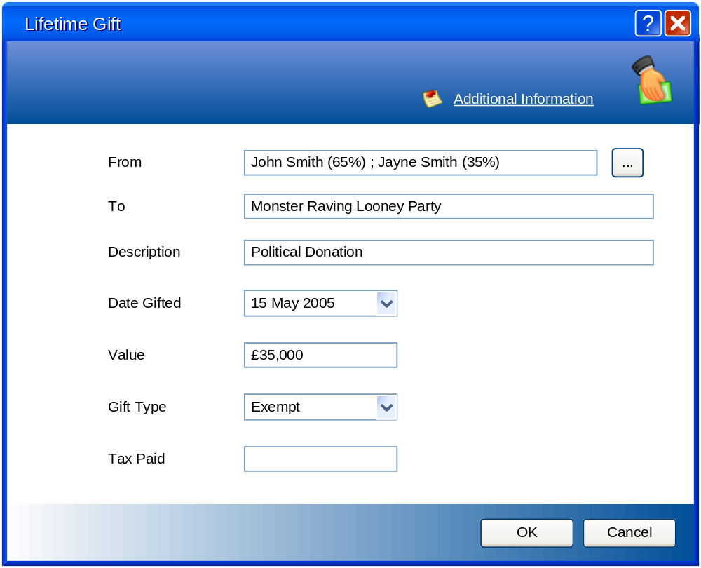

Fields
Field | Comments
Gift Detail
From | Mandatory  Always displayed and enabled except read only if current case context is Present Advice, Application or Completion.  Ownership control (OL1) that includes percentage split for each contact that is providing the gift
To | Mandatory  Always displayed and enabled except read only if current case context is Present Advice, Application or Completion.  Text (chars – check AO db size)  This is a free format text description that provides details of who received the gift (this may be an individual or organisation)
Description | Mandatory  Always displayed and enabled except read only if current case context is Present Advice, Application or Completion.  Text (chars – check AO db size)  This is a free format text description that provides more details for the gift
Date Gifted | Mandatory  Always displayed and enabled except read only if current case context is Present Advice, Application or Completion.  Date field  This is the date of the gift
Amount | Always displayed and enabled except read only if current case context is Present Advice, Application or Completion.  Currency field (no decimal)  The amount of the gift
Gift Type | Mandatory  Always displayed and enabled except read only if current case context is Present Advice, Application or Completion.  Closed list with the following options:  - Exempt  - Potentially Exempt  - Chargeable
Tax Paid | Always displayed and enabled except read only if current case context is Present Advice, Application or Completion.  Currency field (no decimal )  Where a gift is chargeable the tax paid can be entered  Note: No check is made by the system to confirm that this is the correct amount as rates may change over time.

Commands
Command | Comments
Additional Expenditure item
Additional Information | Always displayed and enabled  Link  On selection standard additional information dialog is invoked populated with any notes associated with the dialog
OK | On Selection:  Changes are stored pending next save and close inspector.
Cancel | On Selection:  Abandons any changes made and close inspector.

Value of Estate on Death EP3
Filter Bar

Commands

IHT Tax Assessment IT1-1 & IT1-2

The IHT Tax Assessment dialog enables the user to review a detailed breakdown of the calculation of the Net IHT payable for the selected scenario

This dialog is invoked by selection of the Net IHT Payable link.

There are 2 variants of the dialog which allow the user to review the details of any spousal transfer for a 1st death scenario and the effect of a will on the disposal of oldest client to die.

The system displays the value of the taxable estate (excluding gifts) (Value A – Value B) and then applies any of the following deduction that may be applied
- Business Relief This is a selectable checkbox that on selection enabled the user to record the amount of the taxable estate that receives business relief. (only enabled for current position)
- Agricultural Relief This is a selectable checkbox that on selection enabled the user to record the amount of the taxable estate that receives business relief. (only enabled for current position)
- Spousal Transfer Only displayed on 1st death scenarios where the individuals being assessed are married. This indicates if a will exists (and includes a nil rate band provision) and displays the Calculated Exempt Transfer to spouse. The user can select to make an adjustment to this value to take into account potential inaccuracies in the calculated value.

- Reduction in estate on 1st death only displayed on joint death scenarios where the individuals being assessed are married. This indicates if a will exists (and includes a nil rate band provision) and displays the Calculated Exempt Transfer to spouse. The user can select to make an adjustment to this value to take into account potential inaccuracies in the calculated value.

- Nil Rate Band This is the value of the Nil Rate band less any taxable gifts made in the previous 7 years (by date).

The system add to this calculated value (Estate subject to IHT) the value of any gifts made in the previous 7 years (by date) that are chargeable (i.e. the value of a potentially exempt or chargeable gift that is above the available nil rate band after it has been deducted by any earlier non exempt gifts in the previous 7 years (by date) and any chargeable gifts made in the seven years before the gift was made).

The system then applies the gross IHT rate (currently 40%) to calculate the gross IHT payable, before deducting any tax that has been paid on lifetime gifts and any taper relief on potential exempt gifts (see 4.3- Calculation of IHT Taper Relief for Gifts) and displays the Net IHT Payable

IHT Tax Assessment – 1st Death scenario IT1-1
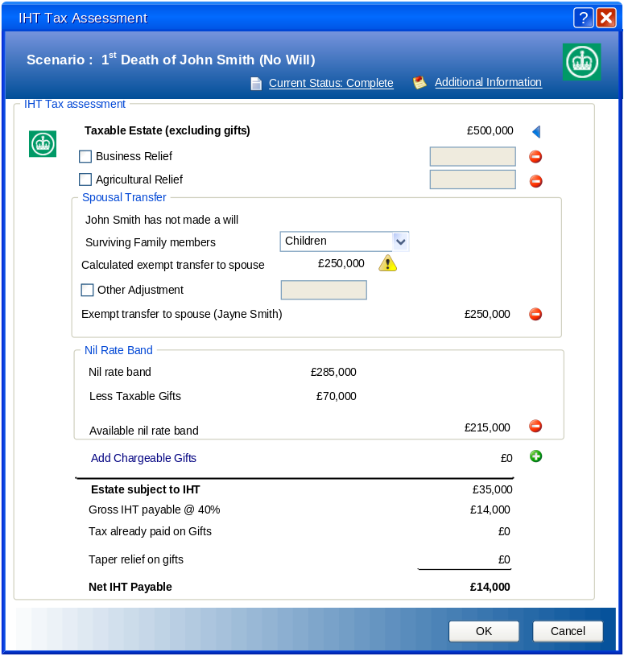

IHT Tax Assessment – 2nd Death scenario IT1-2
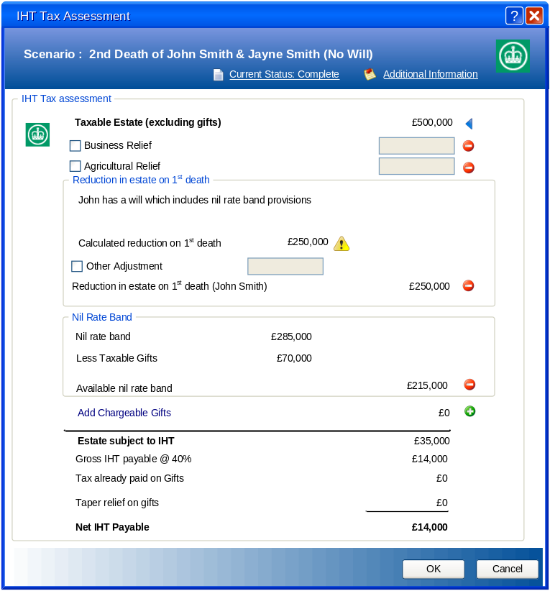

Fields
Field | Comments
IHT Tax Assessment
Taxable Estate (excluding gifts) | Always displayed and read only  Label – currency (no decimals) - Bold  Value = Value of Estate on Death – Assets written in trust ( Value A – Value B)  Value E
Business Relief – Checkbox | Always displayed and enabled except read only if current case context is Present Advice, Application or Completion.  Checkbox – default NOT selected  On Selection enabled Business Relief – Value  On Deselection disable Business Relief – Value (value is ignored and cleared on saving changes)
Business Relief - Value | Conditional – If Business Relief – Checkbox is selected then value must be > 0  Always displayed  Enabled if Business Relief – Checkbox is selected and current case context is NOT Present Advice, Application or Completion.  Read only if Business Relief – Checkbox is selected and current case context is Present Advice, Application or Completion.  Disabled if Business Relief – Checkbox is NOT selected  Currency (no decimals)  This is the value of any business relief that can be used to reduce taxable estate  Value G1
Agricultural Relief – Checkbox | Always displayed and enabled except read only if current case context is Present Advice, Application or Completion.  Checkbox – default NOT selected  On Selection enabled Agricultural Relief – Value  On Deselection disable Agricultural Relief – Value (value is ignored and cleared on saving changes)
Agricultural Relief - Value | Conditional – If Agricultural Relief – Checkbox is selected then value must be > 0  Always displayed  Enabled if Agricultural Relief – Checkbox is selected and current case context is NOT Present Advice, Application or Completion.  Read only if Agricultural Relief – Checkbox is selected and current case context is Present Advice, Application or Completion.  Disabled if Agricultural Relief – Checkbox is NOT selected  Currency (no decimals)  This is the value of any Agricultural relief that can be used to reduce taxable estate  Value G2
Spousal Transfer - section | Only displayed if 1st death scenario being assessed and martial status of individual being assessed is “Married” or “Separated”  Section – see Spousal Transfer for details  This provides the value of the exempt transfer to the surviving spouse  Value G3
Reduction in Estate on 1st death l - section | Only displayed if a joint death scenario been assessed  Section – see Reduction in Estate on 1st Death for details  Value G4
Nil rate band [name] | Always displayed and read only  Label – currency (no decimals)  If 1st Death scenario then = annual gift exemption value (currently £3,000)  Value G5
Less Taxable gifts | Always displayed and read only  Label – currency (no decimals)  Sum of all non exempt gifts (value -exemptions ) that are within 7 years ( by date)  Value G6
Available nil rate band | Always displayed and read only  Label – currency (no decimals)  Derived value  Value = If Value G5 – Value G6 < 0, 0 , Value G5 – Value G6  Value G7
Add Chargeable Gifts – Link | Always displayed and enabled  Link  On selection invokes Lifetime Gifts GD1-2 dialog populated with calculations for the selected scenario
Add Chargeable Gifts – Value | Always displayed and Read only  Label – currency (no decimals) - Bold  Derived value – sum of the any NON exempt gifts made in last seven years that is in excess of its available nil rate band (see Calculation of IHT Taper Relief for Gifts)  Value G8
Estate Subject to IHT | Always displayed and read only  Label – currency (no decimals) - Bold  Derived value  If 1st death scenario then  Value = E less sum(G1*+G2*+G3**+G7) +G8  Else  Value = E less sum(G1*+G2*+G4+G7) + G8  End If  This is the amount of the estate that is subject to IHT  Value G9  * Value only included if associated checkbox selected  ** Value only included if individual being assessed is married
Gross IHT payable @ [IHT rate] | Always displayed and read only  Label – currency (no decimals)  Derived value  Value = G9 * [IHT rate] (currently 40%)  Value G10  Note: The IHT rate should be expressed as a percentage
Tax Already paid on gifts | Always displayed and read only  Label – currency (no decimals)  Derived value  Value = sum of tax paid on taxable gifts (i.e. those within 7 years) from Lifetime Gifts GD1-2  Value G11
Taper Relief on gifts | Always displayed and read only  Label – currency (no decimals)  Derived value  Value = calculated value of relief that applies to any Potential Exempt transfers made in last seven years  See 4.3 - Calculation of IHT Taper Relief for Gifts for details of calculation  Value G12
Net IHT Payable | Always displayed and read only  Label – currency (no decimals) - Bold  Derived value  Value = G10 less sum (G11 + G12)  This is the amount of the potential inheritance tax due on the estate of the individual(s) been assessed  Value G

Spousal Transfer

This section is only displayed if a 1st death scenario for a married individual is being assessed.

The system indicates if the individual has a will and whether this includes any nil rate band provisions.

Where no will exist the system defaults the basis of surviving family members from the relationships of the deceased individual, but the user may alter this as some relatives may not be recorded. The exception is where children exist. In this case the value cannot be amended.

The system displays the calculated value of exempt transfer to the spouse (see 4.1- Calculated Exempt Transfer to spouse) together with a warning icon that on selection displays a warning that the calculated value is based on a basic calculation and the user should be satisfied that it is correct.

The user can select to adjust this value (including reduction by entering a negative value) and the system displays the adjusted value of the exempt transfer.

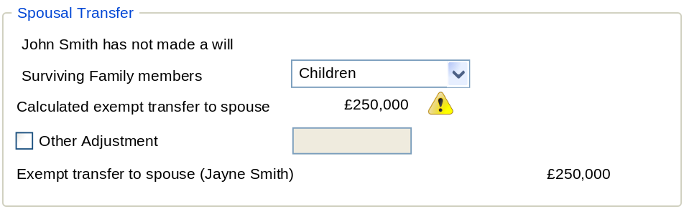

Command | Comments
Spousal Transfer
Will –Text | Always displayed, but read only  Estate Planning – Course of Action EP2  Estate Planning – Current Position EP1  Label – text string  If Will exists then  If Nil rate band provisions have been made then  Value = [name of deceased] has a will which includes nil rate band provisions  Else  Value = [name of deceased] has a will  End If  Else  Value = [name of deceased] has not made a willEstate Planning – Course of Action EP2
Surviving Family Members | Only displayed if no will exists. When displayed enabled unless enabled except read only if current case context is Present Advice, Application or Completion.  Closed list with the following options:  - Descendants  - Immediate Family  - None  If one of more relationships exist with children or grandchildren then system defaults value to “Descendants” and list becomes read only  Else if one or more relationships exist with Parent, Relative or Grandparent then system defaults value to “Other Family”. The list is NOT disabled  Else the list defaults to None. The list is NOT disabled  Note: The user may still select “Descendants” even if no related individual exist.  Estate Planning – Current Position EP1  Estate Planning – Course of Action EP2
Calculated Exempt transfer to spouse | Always displayed and read only  Label – currency (no decimals)  Derived value  Value = calculated value of Exempt transfer or spouse based on Will Exists / Create Will - checkbox and Nil Rate Band Provisions - checkbox selection  See 4.1- Calculated Exempt Transfer to spouse for details of calculation  Value G3A
Calculated Exempt transfer to spouse - warning | Always Displayed and enabled  Warning Icon  On Selection displays information dialog that provides the following message  “The calculation of the exempt transfer value has been made on the assumption that both the deceased and the survivor are UK Domicile for IHT purposes.  The calculated value is based on the information contained in the financial review. This may exclude information that would affect the actual exemption that would be applied. You may need to make a manual adjustment to the value using the other adjustment field.  Details of the calculation method can be found in the help file”.  Note: If possible a link to the appropriate page of the help text will be provided.
Other Adjustment – checkbox (Current Position) | Always displayed Estate Planning – Current Position EP1but only enabled  if current case context is NOT Present Advice, Application or Completion  Checkbox  On Selection enabled Other Adjustment – Value (Current Position)  On Deselection disable Other Adjustment – Value (Current Position) (value is ignored and cleared on saving changes)
Other Adjustment – Value (Current Position) | Conditional – If Other Adjustment – checkbox (Current Position)is selected then value must be > 0  Always displayed Estate Planning – Current Position EP1but only enabled  if Other Adjustment – checkbox (Current Position) is selected and current case context is NOT Present Advice, Application or Completion.  Read only if Other Adjustment – checkbox (Current Position) is selected and current case context is Present Advice, Application or Completion.  Disabled Other Adjustment – checkbox (Current Position) is NOT selected  Currency (no decimals)  This is the value of any business relief that can be used to reduce taxable estate for the current position  Value G3B
Estate Planning – Course of Action EP2

Estate Planning – Current Position EP1

Estate Planning – Course of Action EP2

Estate Planning – Current Position EP1

Exempt transfer to spouse [name] | Always displayed and read only  Label – currency (no decimals)  Derived value  Value = G3A + G3B  Value G3

Reduction in Estate on 1st Death

This section is only displayed if a joint death scenario is being assessed.

The system indicates if the oldest individual has a will (this defaults from the estate planning section of the financial review) and whether it has nil rate band provsions.

Where no will exist the system defaults the basis of surviving family members from the relationships of the deceased individual, but the user may alter this as some relatives may not be recorded. The exception is where children exist. In this case the value cannot be amended.

The system displays the calculated value of the gifted value out of the estate (see 4.2 - Calculated Reduction on 1st death) together with a warning icon that on selection displays a warning that the calculated value is based on a basic calculation and the user should be satisfied that it is correct.

The user can select to adjust this value (including reduction by entering a negative value) and the system displays the adjusted value of the reduction in estate on 1st death of the older individual

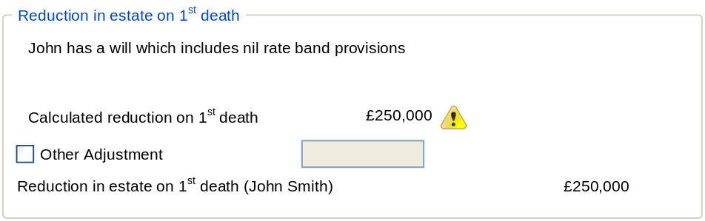
Note: Surviving family member not displayed as in example deceased has a will

Command | Comments
Reduction in estate on 1st death
Will –Text | Always displayed, but read only  Label – text string  If Will exists then  If Nil rate band provisions have been made then  Value = [name of deceased] has a will which includes nil rate band provisions  Else  Value = [name of deceased] has a will  End If  Else  Value = [name of deceased] has not made a will  Estate Planning – Course of Action EP2  Estate Planning – Current Position EP1  Estate Planning – Course of Action EP2
Surviving Family Members | Only displayed if no will exists. When displayed enabled unless enabled except read only if current case context is Present Advice, Application or Completion.  Closed list with the following options:  - Descendants  - Other Family  - None  If one of more relationships exist with children or grandchildren then system defaults value to “Descendants” and list becomes read only  Else if one or more relationships exist with Parent, Relative or Grandparent then system defaults value to “Immediate Family” . The list is NOT disabled  Else the list defaults to None. The list is NOT disabled  Note: The user may still select “Descendants” even if no related individual exist.  Estate Planning – Current Position EP1  Estate Planning – Course of Action EP2
Calculated reduction on 1st Death | Always displayed and read only  Label – currency (no decimals)  Derived value  Value = calculated value of reduction in estate based on Will Exists / Create Will - checkbox and Nil Rate Band Provisions - checkbox selection  See 4.2 - Calculated Reduction on 1st death for details of calculation  Value G4A
Calculated redcution - warning | Always Displayed and enabled  Warning Icon  On Selection displays information dialog that provides the following message  “The calculated value is based on the information contained in the financial review. This may exclude information that would affect the actual exemption that would be applied. You may need to make a manual adjustment to the value using the other adjustment field.  Details of the calculation method can be found in the help file”.  Note: If possible a link to the appropriate page of the help text will be provided.
Other Adjustment – checkbox (Current Position) | Always displayed and enabled Estate Planning – Current Position EP1  if current case context is NOT Present Advice, Application or Completion  Checkbox  On Selection enabled Other Adjustment – Value (Current Position)  On Deselection disable Other Adjustment – Value (Current Position) (value is ignored and cleared on saving changes)
Other Adjustment – Value (Current Position) | Conditional – If Other Adjustment – checkbox (Current Position)is selected then value must be > 0  Always displayed and enabled if Estate Planning – Current Position EP1  Other Adjustment – checkbox (Current Position) is selected and current case context is NOT Present Advice, Application or Completion.  Read only Other Adjustment – checkbox (Current Position) is selected and current case context is Present Advice, Application or Completion.  Disabled Other Adjustment – checkbox (Current Position) is NOT selected  Currency (no decimals)  Value G4B
Estate Planning – Course of Action EP2

Estate Planning – Current Position EP1

Estate Planning – Course of Action EP2

Estate Planning – Current Position EP1

Reduction in estate on 1st death [name] | Always displayed and read only  Label – currency (no decimals)  Derived value  Value = G4A + G4B  Value G4

Commands
Command | Comments
Value of Estate
Dialog Status | Always displayed and enabled except read only if current case context is Application or Completion.  The dialog status is a standard control that is used on all needs analysis screens. It is used to display / set the current status of the page / dialog being reviewed.  The control is view in the header as a link but on selection reverts to a list with the following options:  - Incomplete  - Complete  - Review (initial default)  The system may set the dialog status automatically on entry or require the user to make a selection.  The system contains a global parameter that determines the length of time prior that a dialog can remain in the status of “Complete” and the current case status NOT is Application or Completion. This is set as a number of days after which the status is automatically set to “Review”  Note: If dialog status is “Incomplete” then time limit does not apply
Additional Information | Always displayed and enabled  Link  On selection standard additional information dialog is invoked populated with any notes associated with the dialog
OK | On Selection:  If any conditional value is invalid the following error is displayed  “The following items have been selected but no value has been entered:  [Items]”  Changes are stored pending next save and close inspector.
Cancel | On Selection:  Abandons any changes made and close inspector.

Trust Changes

This section details the changes to the Trust and Beneficiary details section on the additional details page of plans, investment holdings, cash accounts and assets.

The “In Trust” checkbox will be added to the Usage section and include a link called trust details. This will appear on all plans, investment holdings, cash accounts and assets.

The link fields will be displayed but disabled unless the checkbox is selected. On selection of the link the system will invoke the trust details dialog.

Trust Details TD1

The trust details dialog enables the user to confirm if the trust is still considered part of the estate of the owners and record detail of the chargeable event. The system displays the date when the trust is free of any potential IHT charge. The user can also confirm if the surviving partner is a beneficiary. Where this occurs the user can indicate the percentage of the value at death or a specific amount that is passed to other beneficiaries
Note: The setting of a spouse value will not affect the IHT payable on 1st death and it is assumed that the trust / will contain clauses to prevent transfer to partner on joint death. The purpose is to identify the amount of the deceases estate that remains with the partner for financial planning purposes (for example the ability to realised an asset to provide ongoing income for the surviving partner)

The trust details enable the user to record the details of the beneficiaries and trustees.

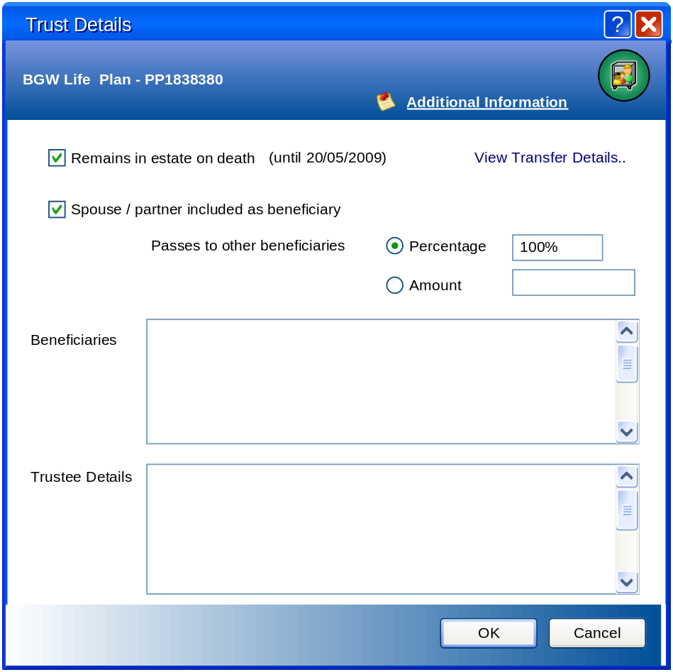

Fields
Field | Comments
Trust Detail
When reviewed in a case any enabled field will be read if current case context is Formulate Advice Present Advice, Application or Completion.
Remains in estate on death | Always displayed and enabled.  Checkbox – default NOT selected  On selection enables View Transfer Details link  On deselection disables View Transfer Details link  Note: On selection of Ok if the user has deselected the option and a Lifetime Gift is linked to the provision then the system will display a warning that if they continue the Lifetime Gift will be removed. If the user continues the Lifetime Gift is marked as deleted and no long displayed.
View Transfer Details | Always displayed but only enabled if Remains in estate on death is selected.  Link  On selection  If no lifetime gift has been previously created the system invoke the Lifetime Gift dialog and pre-populates the dialog with the following information:  From = Owners of provision  Split (client) = based on any split of provision  To = user must complete  Description = provision description  Date Gifted = Commencement / acquisition date of provision (if present)  Value = Value at Commencement / acquisition  Gift Type = Potentially Except  Tax Paid = 0  Else  The system invoke the Lifetime Gift dialog and populates it with the current information  The user may change any of the information.  (see Lifetime Gifts GD1-2 and Gift Detail GD1 )
Spouse / partner included as beneficiary | Always displayed and enabled.  Checkbox – default NOT selected  On selection enables Passes to other beneficiaries - Percentage – radio button and Passes to other beneficiaries - Amount – radio button  On deselection disables Passes to other beneficiaries - Percentage – radio button and Passes to other beneficiaries - Amount – radio button
Passes to other beneficiaries - Percentage – radio button | Always displayed but only enabled if Spouse / partner included as beneficiary is selected.  Radio Button – default selected  On selection enable Passes to other beneficiaries - Percentage – value  On deselection disable Passes to other beneficiaries - Percentage - value
Passes to other beneficiaries - Percentage - value | Conditional – value must be > 0 if enabled  Always displayed but only enabled if Spouse / partner included as beneficiary is selected and Passes to other beneficiaries - Percentage – radio button is selected  Percentage (no decimals)  This is the percentage of the provision that will not pass to the spouse / partner
Passes to other beneficiaries - Amount – radio button | Always displayed but only enabled if Spouse / partner included as beneficiary is selected.  Radio Button – default selected  On selection enable Passes to other beneficiaries - Amount – value  On deselection disable Passes to other beneficiaries - Amount - value
Passes to other beneficiaries - Amount - value | Conditional – value must be > 0 if enabled  Always displayed but only enabled if Spouse / partner included as beneficiary is selected and Passes to other beneficiaries - Amount – radio button is selected  Currency (no decimals)  This is the amount of the provision that will not pass to the spouse / partner
Beneficiaries | Always displayed and enabled.  Text ( free format)  Used to record the details of the beneficiaries of the trust
Trustee Details | Always displayed and enabled.  Text ( free format)  Used to record the details of the beneficiaries of the trust

Commands
Command | Comments
Additional Expenditure item
Additional Information | Always displayed and enabled  Link  On selection standard additional information dialog is invoked populated with any notes associated with the dialog
OK | On Selection:  If any conditional value is invalid the following error is displayed  “The following items have been selected but no value has been entered:  [Items]”  Else if the user has changed the selection of Remains in estate on death to deselected the system displayed the following warning:  “If you continue the link Lifetime gift associated with the trsut remaining in estate will be removed. Do you wish to continue? – option Yes / No (default)  Else if Remains in estate on death is selected and there is no linked Lifetime Gift the following error is displayed:  “you must record details of the chargeable event before saving the changes”  Else Cchanges are stored pending next save and close inspector.
Cncel | On Selection:  Abandons any changes made and close inspector.

Checking for existence of Will

Each time the user attempt to invoke the estate planning module then a check is made to ensure that all the individuals have stated whether they have a will. If any individual being assessed has not specified the system requests that this is done before allowing access to the estate planning module. If the user select to process the system invokes the Will Confirmation WC1 dialog populated with the current will details for all the individuals being assessed identifying which answer needs correcting.

If both have wills, but an individual being assessed has identified that they are gifting items out of his / her estate on death and they have indicated that they do not have a will then the system will not let them access the estate planning until they have confirmed that a will exists. If no will exists then the user should remove the gifting from the property assets (a new managed column will be added to the property list to enable the presence of gifting to be easily identified). . If the user select to proceed the system invokes the Will Confirmation WC1 dialog populated with the current will details for all the individuals being assessed identifying which answer needs correcting.

Will Confirmation WC1

This displays the current answers to the will questions from the estate planning page of the financial review in order for the user to provide confirmation of the existence of a will where it has either not been confirmed or where an individual has indicated that they have not made a will, but indicated that he / she is gifting part of his / her estate on death.

The system indicates any field that is not valid and disables the continue command until a valid answer is provided.

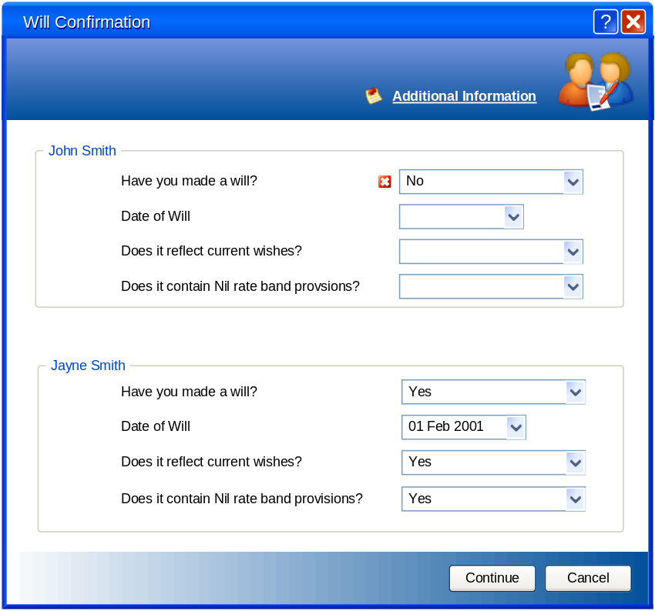

Fields
Field | Comments
Gift Detail
A separate section is displayed for each individual being assessed. The detail of a single section are provided
Have you made a will? | Always displayed and enabled.  List containing the following options:  - Yes  - No  - Not Disclosed  - Not Answered  - Not Known  The system populated the value based on the current value of the associated question on the estate planning page of the financial review (fact find) for the individual. Any changes will update the associated field on selection of Continue command.  If the value is set as “Not Disclosed”, ”Not Answered” or “Not Known” then the system indicates that it is an invalid selection and the Continue command is disabled.  Else If the value if “No” then  If there are one of more property assets owned (part owned) by the individual and the Gifted out of estate checkbox for the individual is selected then the system indicates that it is an invalid selection and the Continue command is disabled.  Else Continue command is enabled (subject to any other field validation)  End If  Else (i.e. “Yes”) Continue command is enabled (subject to any other field validation)  End If  On selection of “Yes” the Date of Will and Does it reflect current wishes? fields are enabled  On changing selection from “Yes” the” the Date of Will and Does it reflect current wishes? fields are disabled (values are held and only cleared on selection of Continue command.
Date of Will | Always displayed, but only enabled if Have you made a will? = “Yes”  Date field  The system populated the value based on the current value of the associated question on the estate planning page of the financial review (fact find) for the individual. Any changes will update the associated field on selection of Continue command.
Does it reflect current wishes? | Always displayed, but only enabled if Have you made a will? = “Yes”  Date field  List containing the following options:  - Yes  - No  - Not Disclosed  - Not Answered  - Not Known  The system populated the value based on the current value of the associated question on the estate planning page of the financial review (fact find) for the individual. Any changes will update the associated field on selection of Continue command.
Does it contain Nil rate band provisions? | Always displayed, but only enabled if Have you made a will? = “Yes”  Date field  List containing the following options:  - Yes  - No  - Not Disclosed  - Not Answered  - Not Known  The system populated the value based on the current value of the associated question on the estate planning page of the financial review (fact find) for the individual. Any changes will update the associated field on selection of Continue command.

Commands
Command | Comments
Additional Expenditure item
Additional Information | Always displayed and enabled  Link  On selection standard additional information dialog is invoked populated with any notes associated with the dialog
Continue | Always displayed, but only enable if there are no invalid entries in the will sections for the individuals being assessed.  On Selection:  Changes are applied to appropriate field of estate planning page of financial review and the estate planning module is invoked
Cancel | On Selection:  Abandons any changes made and close inspector.

Gifted out of estate on death

This section details the changes to the usage section on additional death page of a property. This enables the recording of the presence of a gifted disbursement on death of the property as part of a will

Where the Ownership basis is set as “Tenants in common” then checkbox will be included called “Gifted outside of estate on death” with a link called “gift details” that is only enabled when the checkbox is selected.

On selection of the checkbox the system validates if the “Have you made a will?” question on the estate planning page of the financial review is set to “Yes”. If it is not set (regardless of the inclusion of the estate planning page in the financial review) then the system display the following message:
“In order to gift items on death you must have an up to date will. Do you wish to continue?”
If the user continues the system set the answer to the “Have you made a will?” question as “Yes”
Note: If the user subsequently changes the “Have you made a will?” question back the system will not check for gifted items.

On selection of the link a dialog is displayed that enables the user to confirm for each owner whether the gifting is a nil rate band trust, a percentage of the value or a specific amount.

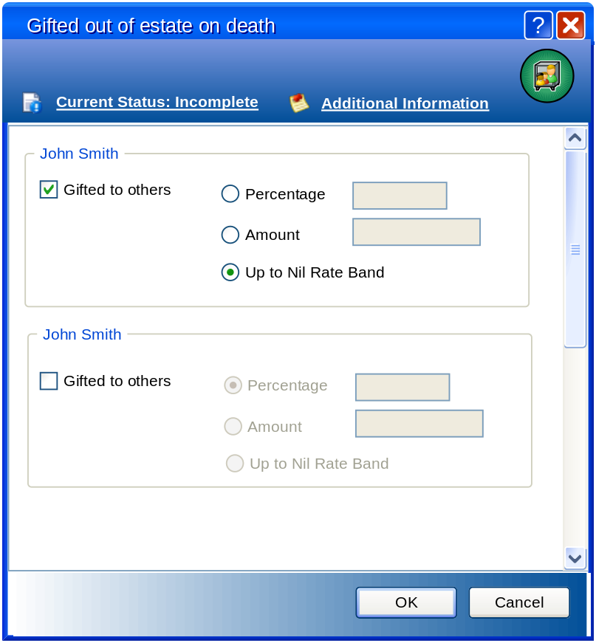

Fields
Field | Comments
Gifted outside of estate on death
A separate section is displayed for each individual being assessed. The detail of a single section are provided
Gifted to Other - checkbox | Always displayed and enabled.  Checkbox – default NOT selected  On selection the enable Percentage – radio button, Amount – radio button and Up to Nil Rate – radio button  On changing selection from “Yes” the” the Date of Will and Does it reflect current wishes? fields are disabled (values are held and only cleared on selection of Continue command.
Gifted To Other - Percentage – radio button | Always displayed but only enabled if Gifted To Other – checkbox is selected.  Radio Button – default selected  On selection enable Gifted To Other - Percentage – value  On deselection disable Gifted To Other - Percentage - value
Gifted To Other - Percentage - value | Conditional – value must be > 0 if enabled  Always displayed but only enabled if Gifted To Other - checkbox is selected and Gifted To Other - Percentage – radio button is selected  Percentage (no decimals)  This is the percentage of the provision that will not pass to the spouse / partner
Gifted To Other - Amount – radio button | Always displayed but only enabled if Gifted To Other - checkbox is selected.  Radio Button – default selected  On selection enable Gifted To Other - Amount – value  On deselection disable Gifted To Other - Amount - value
Gifted To Other - Amount - value | Conditional – value must be > 0 if enabled  Always displayed but only enabled if Gifted To Other - checkbox is selected and Gifted To Other - Amount – radio button is selected  Currency (no decimals)  This is the amount of the provision that will not pass to the spouse / partner
Gifted To Other - Up to Nil Rate Band – radio button | Always displayed but only enabled if Gifted To Other - checkbox is selected.  Radio Button – default selected  On selection enable Gifted To Other - Percentage – value  On deselection disable Gifted To Other - Percentage - value

Commands
Command | Comments
Additional Expenditure item
Dialog Status | Always displayed and enabled except read only if current case context is Application or Completion.  The dialog status is a standard control that is used on all needs analysis screens. It is used to display / set the current status of the page / dialog being reviewed.  The control is view in the header as a link but on selection reverts to a list with the following options:  - Incomplete  - Complete  - Review (initial default)  The system may set the dialog status automatically on entry or require the user to make a selection.  The system contains a global parameter that determines the length of time prior that a dialog can remain in the status of “Complete” and the current case status NOT is Application or Completion. This is set as a number of days after which the status is automatically set to “Review”  Note: If dialog status is “Incomplete” then time limit does not apply
Additional Information | Always displayed and enabled  Link  On selection standard additional information dialog is invoked populated with any notes associated with the dialog
Ok | On Selection:  If no Gifted to Other selection has been made then set status to “Incomplete”  Changes are stored pending next save and close inspector.
Cancel | On Selection:  Abandons any changes made and close inspector.

System Impact Analysis

Detail the potential impact on users, external forces that may impact, points to be aware of, testing considerations. How this will fit in with or impact upon existing functionality. Where any existing reports are affected these should be referred to including report reference number.

This is a new area to Adviser Evolution and is based on the existing functionality for estate planning within Adviser Office.

It incorporates a change to the way trusts is record that has been previously requested by the Financial Planning User Group to enable trusts what include spouses to be identified and therefore remain liable to IHT on second death.

New fields required in Financial Review (fact find pages)
The following new values needs to be included on the Allowance tab of the Tax, NIC & Allowances dialog
Item | Value | Comments
Non Domicile Spouse IHT Exemption | £55,000 | Not used in current implementation – added for information purposes
Annual gift exemption | £3,000
England & Wales – Statutory Legacy - Children | £125,000
England & Wales – Statutory Legacy – Immediate Relatives | £200,000
England & Wales – Life Interest percentage | 50.00%
Scotland – Prior Rights – Main Residence | £300,000
Scotland – Prior Rights – Furnishings | £24,000
Scotland – Prior Rights – Other Estate - Children | £42,000
Scotland – Prior Rights – Other Estate – No Children | £75,000
Scotland – Legal Rights – Moveable Estate – Children | 33.33%
Scotland – Legal Rights – Moveable Estate – No Children | 50.00%
Northern Ireland - Statutory Legacy - Children | £125,000 | Although this is same as England and Wales separate values are maintained
Northern Ireland - Statutory Legacy – Immediate Relatives | £200,000 | Although this is same as England and Wales separate values are maintained
Northern Ireland - Residue - percentage | 50.00%
Default Location |  | Closed list containing the following options:  - England and Wales  - Northern Ireland  - Scotland  This is always enabled so that the user can select personal default value.

A new field is required that should be added to the Estate Planning page of the Financial report. This should be a check box that is to the immediate right of the “Have you made a will?” field. This will only be enabled if the selection “Have you made a will?” field is Yes. The checkbox is labelled “Includes nil rate band provisions”. The initial default is deselected.

New additional fields on property assets are required to enable the user to indicate if any of the value is being gifted out of the estate on death. Selection of this option will force the have you made a Will question to be set to “Yes” (See Gifted out of estate on death for details).

The trust section of assets needs to be corrected to only include the selection checkbox as part of the usage section (i.e. as originally designed) with a link to invoke the trusts dialog (see 3.11- Trust Changes for details).
Note: This also affects the expression of wish checkbox

These changes should be replicated in Adviser Office to ensure that we maintain a compatible assessment regardless of the system used.

Suitability Reports
The ability to propose making a will and including a nil rate band provisions requires that these exist as part of the non product proposal when the financial advice process case template include estate planning. This has a knock on implication to the creation of non product need / sub needs where a report writer is used to create suitability reports.

Assumptions

A new section is required in the Financial Objectives Assumptions (See AE - Needs Analysis - Retirement Planning 1610309b.doc for details of other items) that will hold the basis for calculating the spousal transfer value (see Calculated Exempt Transfer to spouse)

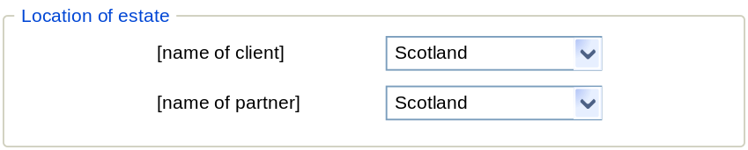

Location of Estate - Client | Always displayed and enabled.  Label = name of client  Closed list containing the following options:  - England and Wales  - Northern Ireland  - Scotland  The initial default option will be a user configurable value  On selection the Apply command if the system will recalculate the spousal transfer value on the death of the client based on the selected option if it has changed
Location of Estate - Client | Only displayed and enabled for joint cases  Label = name of partner  Closed list containing the following options:  - England and Wales  - Northern Ireland  - Scotland  The initial default option will be a user configurable value  On selection the Apply command if the system will recalculate the spousal transfer value on the death of the partner based on the selected option if it has changed

Appendices
E.g. Sample reports
Definitions, terms, acronyms, abbreviations
References – documents, regulations, meeting minutes

Calculated Exempt Transfer to spouse

Transfers of property and gifts between spouses, no matter how large in value, are exempt from Inheritance Tax. This is known as the inter-spouse exemption rule.
The system uses the marital status, will status and location of estate of the individual(s) being assessed to determine the amount of exempt transfer to spouse.

The system will use the Taxable Estate less Business Relief and Agricultural Relief as a base value from which the spousal transfer value is calculated.

The Taxable Estate value already excludes any assets written under trust (that are exempt from IHT) and added back in taxable gifts.

Where NO spousal relationship exists then:

If there is no spouse (or for a joint assessment there is no spousal relationship) then the spousal transfer value = 0. The spousal transfer section of the IHT Tax Assessment IT1 is not displayed.

Where a spousal relationship exists and there is a will then:

The initial spousal transfer is the value of the Taxable estate less Business Relief, Agricultural Relief and the value of any taxable gifts.

From the initial value will be deducted the value of any items gifted on death and any and any property held by the deceased as joint tenants with another individual other than the surviving spouse. Where gifted items have a specific value or percentage of value a full deduction is made regardless of whether this is greater than the nil rate band. Where the sum of taxable gifts, gifted items (with value) and any joint tenant property excluded is less than the nil rate band, then the system deducts the value of any gifted items marked as up to nil rate band to derive the spousal transfer value.

Where a spousal relationship exists and there is NO will then:

No gifted items can be present if no will exists, but items may be in trust. The calculations below are based on excluding any items that are in trust (whether still chargeable), except for any proportion that is for the benefit of the surviving spouse.

Where Surviving Family Member = None then the system allocated the entire value of the estate of the deceased spouse to the surviving spouse

Where Surviving Family Member = Descendants or Other Family then the system calculates the value of the estate that passes to the surviving spouse based on the rules of intestacy for the location of the estate of the deceased (see Assumptions)

Note: It is a training issue for the adviser to understand that Other Family means surviving parents, brothers or sisters, or descendants of brothers and sisters, of the deceased?

Scotland

Where Location of estate = “Scotland” the system calculates the Prior Rights and Legal Rights of the surviving spouse and the sum = spousal transfer value

1. Prior Rights

Any property held as joint tenants (i.e. a 'survivor clause' is registered) between spousal partners is passed directly to the spousal partner (or proportion where more than 2 owners)

If the surviving spouse has an existing current property (not owned with the deceased spouse) of the type “Main Residence” then no additional property transfer is made
Else if the “Main Residence” of the deceased spouse does NOT have tenure of Boarding, Council Rented or Private Rented then the deceased owners share of the current value (this is derived by applying property growth rate to last known value) up to the property threshold (£300,000) is passed to the surviving spouse.
Notes:
- The system assumes that the surviving spouse lives in the same residence as the deceased unless they have a separate property.
- The system does not consider how the value of a property is released if the value owned by the deceased spouse is over £300,000.
- The system will not transfer value if the main residence if it is recorded as held in trust, except for the proportion of the value that is being passed to the surviving spouse

Up to the threshold for Furnishings (£24,000) is taken from the value of other assets owned by the deceased spouse where Fixed Type is Personal Effects / Contents
Note: The assumption is that the value of furniture will be included as part of this value although the exact amount is unknown

If Surviving Family Member = Descendants then a deduct of up to the threshold for Prior Rights – Other Estate – Children (£42,000) is made from the remaining estate (Taxable Estate less Business Relief , Agricultural Relief, Taxable Gifts, Main Residence transfer and Furniture Transfer).
Else if Surviving Family Member = Other Family then a deduct of up to the threshold for Prior Rights – Other Estate – No Children (£75,000) is made from the remaining estate (Taxable Estate less Business Relief , Agricultural Relief, Taxable , Main Residence transfer and Furniture Transfer).

The sum of these values = Prior Rights

2. Legal Rights

The system calculates the value of moveable estate. This is value of Other assets where fixed type is NOT Personal Effects / Contents and investment owned by the deceased spouse

If Surviving Family Member = Descendants then
If estate value - prior rights < moveable estate then
Legal Rights = estate value - prior rights * Moveable Estate – Children (33.33%)
Else
Legal Rights = moveable estate * Moveable Estate – Children (33.33%)
End if
Else
If estate value - prior rights < moveable estate then
Legal Rights = estate value - prior rights * Moveable Estate – No Children (50.00%)
Else
Legal Rights = moveable estate * Moveable Estate – No Children (50.00%)
End if
End if

Where Location of estate = “Scotland” the system calculates the Prior Rights and Legal Rights of the surviving spouse

England & Wales

Where Location of estate = “England & Wales” the system calculates the Spousal Transfer value

If Surviving Family Member = Descendants then
Spousal Transfer Value = Value of Other Assets owned by the deceased spouse {Chattels} + Min (Estate Value – Other Assets, Statutory Legacy – Children (£125,000){Statutory Legacy} + any residue value (Estate Value less Chattels and Statutory Legacy) * Life Interest-Percent (50.00%)
Else (i.e. Surviving Family Member = Other Family) then
Spousal Transfer Value = Value of Other Assets owned by the deceased spouse {Chattels} + Min (Estate Value – Other Assets, Statutory Legacy – Immediate Relatives (£200,000){Statutory Legacy} + any residue value (Estate Value less Chattels and Statutory Legacy) * Life Interest-Percent (50.00%)

Northern Ireland

Where Location of estate = “Northern Ireland” the system calculates the Spousal Transfer value

If Surviving Family Member = Descendants then
If Estate Value < Northern Ireland - Statutory Legacy – Children (£125,000) then
Spousal Transfer Value = Estate Value
Else If Northern Ireland - Statutory Legacy – Children + value of other assets owned by the deceased spouse where Fixed Type is Personal Effects / Contents > Estate Value then
Spousal Transfer Value = Estate Value
Else
Spousal Transfer Value = Northern Ireland - Statutory Legacy – Children + value of other assets owned by the deceased spouse where Fixed Type is Personal Effects / Contents + ( Estate Value less Northern Ireland - Statutory Legacy – Children + value of other assets owned by the deceased spouse where Fixed Type is Personal Effects / Contents) * Northern Ireland - Residue – Percentage (50.00%)
End If
Else (i.e. Surviving Family Member = Other Family) then
If Estate Value < Northern Ireland - Statutory Legacy – No Children (£200,000) then
Spousal Transfer Value = Estate Value
Else If Northern Ireland - Statutory Legacy – No Children + value of other assets owned by the deceased spouse where Fixed Type is Personal Effects / Contents > Estate Value then
Spousal Transfer Value = Estate Value
Else
Spousal Transfer Value = Northern Ireland - Statutory Legacy – No Children + value of other assets owned by the deceased spouse where Fixed Type is Personal Effects / Contents + ( Estate Value less Northern Ireland - Statutory Legacy – No Children + value of other assets owned by the deceased spouse where Fixed Type is Personal Effects / Contents) * Northern Ireland - Residue – percentage
End If
End If

Calculated Reduction on 1st death

Where the joint death of a married couple occurs it is possible to utilise the nil rate band allowance by writing a will in a way that avoids the passing of estate between spouses.

If there is a NO will for the oldest of the married couple then
The value of the amount gifted outside of the estate is £0 and the user cannot make any adjustment to the value
Else
If it includes nil rate band provisions then
The value is equal to the lower of the taxable estate on death of the older individual (as for 1st client scenario) and (higher of nil rate band - any taxable gifts and £0). Note: This excludes any business or agricultural relief. The user can adjust the value applied using the other adjustment field.
Else
The value is equal to the lower of the sum of all items gifted outside estate on death to other beneficiaries (see Error: Reference source not found) and the nil rate band. Note: This excludes any other items gifted in the will that may be included in the will. The user can adjust the value applied using the other adjustment field.

Calculation of IHT Taper Relief for Gifts

Taper relief is provided where an individual makes a gift and then dies within a seven year period. Taper relief is only available if the gift exceeds the available nil rate band calculated.

Each of the gifts is eligible for an annual exemption and this should be first deducted from the value. £3000 is the annual exemption each tax year.

Where a gift (excluding exempt gifts) has not been made in the previous tax year, the gift is subject to £6000 exemption. Therefore the first gift is always subject to £6000 annual exemption. If any surplus exists in the annual exemption it is carried forward one tax year.

When assessing whether a gift is within the nil rate band a check has to be made for earlier gifts made within 7 year of the assessment (excluding exempt gifts) and the value of any chargeable gift made in the previous seven years to when the gift was made. The available nil rate band is the higher of 0 or the value of the gifts identified

If a gift (or part of a gift) is above it’s available nil rate band then the tax on that proportion is reduced as follows

Years between gift and death | Percentage of full charge applied
Less than 3 years | 100%
3 – 4 years | 80%
4 -5 years | 60%
5 – 6 years | 40%
6 – 7 years | 20%

See IHT calculations spreadsheet for a worked example

Assumptions

The following assumption have been made
- In each scenario the death of the individual(s) being assessed is immediate
- Individuals being assessed are treated as UK-domiciled for IHT purposes

- Where all the individuals being assessed have a marital status of married then the system assumes that they have a spousal relationship (marriage or civil partnership)
- Where the individuals are not married (i.e. one of the individuals does not have a marital status of married) the system assumes that inheritance tax is payable on the assets of the individual.
- In a joint death scenario the system bases the calculation on assessing the death of the oldest individual first and any exclusion is applied to that individual only. Any exclusion applied to the younger individual is ignored as they are assumed to have no surviving spouse.
- For a joint scenario it is assumed that any Will has been written to avoid passing assets to spouse that are held in trust where the partner is a beneficiary and so in this instance the system will ignore any portion that is under trust to the spouse and assume the entire asset is held in trust
- For a joint scenario it is assumed that the any trust / will has been written to avoid passing assets to spouse that are held in trust where the partner is a beneficiary and so in this instance the system will ignore the “Gifted outside of estate on death ” selection and assume the entire asset is held in trust
- It is assumed that the annual gift exemption for IHT purposes is always used to reduce any potential IHT liability.

Authority & Responsibility Sign Off

Name | Position | Signature | Date
Paul Creamer | CTO
Tessa Froggatt | Product Realisation Manager
 | <Insert Client Signatory>
 | <Insert Client Signatory>

All Intellectual Property Rights are and shall remain the property of Independent Specialist Technology (UK) Ltd unless otherwise stated.

An asset is any possession which has value, such as a house, land, cash or securities.

